J.UCS Sample Paper

Anna Musterfrau
(Example University, city, state
https://orcid.org/0000-1234-0000-0002, anna.musterfrau@example.at)

Max Mustermann
(Example University, city, state
https://orcid.org/0000-0000-0000-0000, max.mustermann@example.at)

Abstract: A short and pregnant description of the content and intent of the article. Please try to avoid mathematical symbols and special characters as much as possible. Make sure the heading of the article, the names of the authors and their affiliations are formatted as shown above. State the names of the city and country in the affiliations.

Keywords: MPEG-7, content-based Multimedia Retrieval, Hypermedia systems, Web-based services, XML, Semantic Web, Multimedia
Categories: H.3.1, H.3.2, H.3.3, H.3.7, H.5.1
DOI: 10.3897/jucs.<SubmissionNumber>
- Introduction
Make sure the headings are correctly formatted throughout the article …
- Existing Video Annotation and Retrieval Systems
A variety of projects have designed and implemented multimedia retrieval systems. The focus is on covering multimedia databases, meta-data annotation, specialized multimedia analysis methods and web-based front-ends. A special focus had been laid on projects and systems already using MPEG-7 or providing extended retrieval features. In addition to the usage of MPEG-7 it was important to analyse the level of semantic, that can be described and used…
The first step of annotation is an automatic shot detection tool that recognizes dissolves and fades to detect scene cuts. A couple of key frames for each shot is used to represent the content of each shot. Content description in form of meta-data can be added to each shot by selecting entries from the tree view. The entries are described in MPEG-7 and can be loaded from a separate file to use customized lexicons. Each shot can interactively be annotated with object descriptions, event descriptions, other lexicon sets and own keywords. Finally the annotated video description is saved as MPEG-7 XML file. A lexicon is an MPEG-7 based definition of application dependent description components, that has no standardised format…
  - Ricoh MovieTool
MovieTool is a tool for interactively creating video content descriptions conforming to MPEG-7 syntax [Ricoh, 02]…
- Semantic based Retrieval using Meta data
  - Creation of Meta data
If a subheading is preceded by a higher level heading, the space between them is reduced to 12 pt.
Indent the first line of the second and all subsequent paragraphs. If you use figures, make sure the figures stay within the printing area.
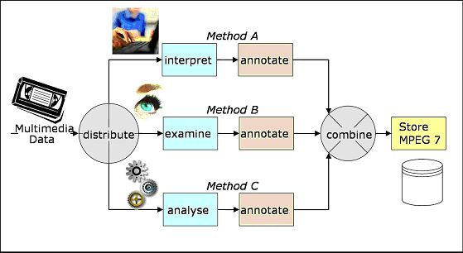
Figure 1: Make sure the captions are italics, centred
The space before and after a caption must be 12pt. Allow enough space (at least 10 pt before the figure.

Label | Type | Relation | Target
Soccer Player #1 | SoccerPlayerType | patientOf | Event red card
Referee | SoccerRefereeType | agentOf | Event red card
Event red card | EventType
Table 2: Make sure the table stays within the printing area. Allow space before the table. The table caption must be formatted in the same way as the figure captions, i.e. italics, 10pt, with 12pt empty space before and after the table caption
- The Retrieval Framework
Our main objective is to design …
- Conclusions
The current work …
- Future Work
In near future …

Acknowledgements
The heading of section ‘Acknowledgement’ must be 10 pt, bold, left justified, with 12pt empty space before and 6pt after. It is absolutely imperative that the references are formatted correctly, i.e. first comes the abbreviation in square brackets, then follows the second name of the author followed by abbreviation of the first name.

References
[Achmed, 99] Ahmed, M., Karmouch, A., Abu-Hakima S.: Key Frame Extraction and Indexing for Multimedia Databases, Vision Interface 1999, Trois-Rivières, Canada, 19-21 May 1999.
[Chakrabarti, 99] Chakrabarti, K., Mehrotra, S.: The Hybrid Tree: An Index Structure for High Dimensional Feature Spaces, In Proc. Int. Conf. on Data Engineering, February 1999, 440-447 http://citeseer.nj.nec.com/chakrabarti99hybrid.html
[Cocoon, 02] Cocoon XML publishing framework, 2002, http://xml.apache.org/cocoon/
[Hunter, 00] Hunter, J.: Proposal for the Integration of DublinCore and MPEG-7, October 2000

